Electronics Report

Description:

Sub-domains:

1. Battery and Battery Management System
2. Hall sensor and State of Charge estimation
3. Speed and distance calculation

I. Battery and Battery Management System:

We have 3 lithium battery packs totalling to 84V. It has a capacity of 75Ah. It can supply a maximum continuous current of 450A. It has an in-built battery management system that monitors the cell voltages, current and temperature. It senses data on real time and take precautionary measures in extreme cases.

Simulation Results:

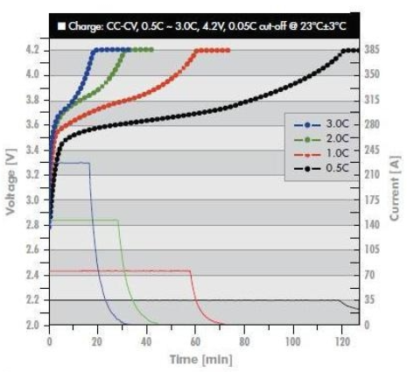 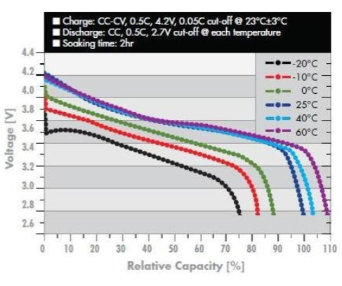

*Charge profiles at room temperature Temperature Characteristics*

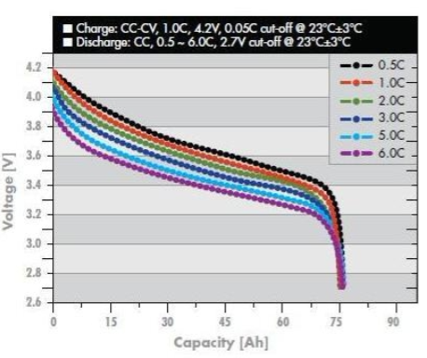

*Discharge profiles at room temperature*

**Comparison of lithium ion polymer cells with lead acid batteries**

1. Weight: Lithium-ion batteries are one-third the weight of lead acid batteries
2. Efficiency: Lithium-ion batteries are nearly 100% efficient in both charge and discharge, allowing for the same amp hours both in and out. Lead acid batteries’ inefficiency leads to a loss of 15 amps while charging and rapid discharging drops voltage quickly and reduces the batteries’ capacity.
3. Discharge: Lithium-ion batteries are discharged 100% versus less than 80% for lead acid. Most lead acid batteries do not recommend more than 50% depth of discharge.
4. Cycle life: Rechargeable lithium ion batteries have a cycle life of 5000 or more compared to just 400-500 cycles in lead acid. Cycle life is greatly affected by higher levels of discharge in lead acid, versus only slightly affected in lithium-ion batteries
5. Voltage: Lithium-ion batteries maintain their voltage throughout the entire discharge cycle. This allows for greater and longer-lasting efficiency of electrical components. Lead acid voltage drops consistently throughout the discharge cycle
6. Cost: Despite the higher upfront cost of lithium-ion batteries, the true cost of ownership is far less than lead acid when considering life span and performance
7. Environmental Impact: Lithium-ion batteries are a much cleaner technology and are safer for the environment

**Comparison of cylindrical cells with pouch cells:**

Cylindrical cells have good mechanical stability and are easy to manufacture. When mounted, they have spaces between them to install thermal regulation solutions.

We chose pouch cells as they are flexible, lightweight and compact. They can deliver high load currents. This significantly increases range and capacity while utilising less weight and volume. The pouch cell makes most efficient use of space and achieves 90–95 percent packaging efficiency, the highest among battery packs.

Pouch cells tend to swell after 5000 cycles( for our cell model). Hence, we spaced the cells at a safe distance to overcome this problem.

**Challenges with lithium ion batteries:**

1. It requires a BMS(battery management system) circuit for overvoltage and overcurrent protection.
2. Cell aging: Degradation upon storage is accelerated at SOC=100% (4.2V)
3. Lithium cells are very susceptible to changes in temperature.

**Charger specifications:**

1. Input: 230 VAC 50 Hz
2. Output: 84V and 20A, charging uses constant voltage and constant current

II. Hall sensor State of Charge estimation:

Circuit Diagram:

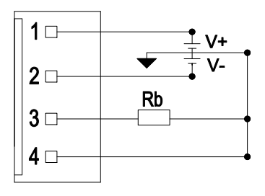

Input and output characteristics:

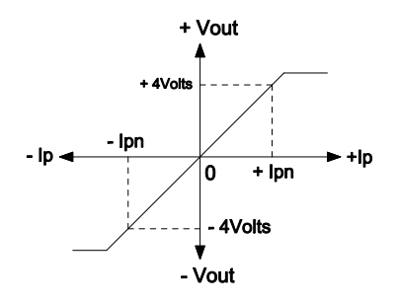

Hall Sensor Specifications:

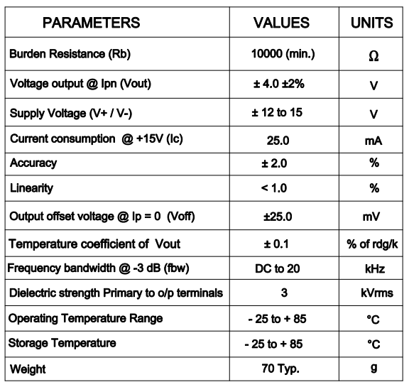

III. Speed and Distance Calculation:

Hall sensor Model Name: AH 180

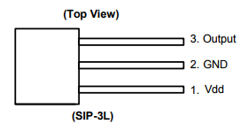

**Features:**

1. Omnipolar (north or south pole) operation
2. Micropower operation S
3. ingle open drain output • 2.5V to 5.5V operating voltage
4. Chopper stabilized design provides
5. Superior temperature stability
6. Minimal switch-point drift
7. Enhanced immunity to stress
8. Good RF noise immunity • -40°C to 85°C operating temperature E
9. SD (HBM) ＞ 5KV for DFN2020-6, DFN2020-3 ＞ 6KV for SIP-3L and SC59
10. SIP-3L, SC59 (commonly known as SOT23 in Asia) DFN2020-6, DFN2020-3 packages • Green Molding Compound (No Br, Sb) (Note 1)

**Pin Description:**

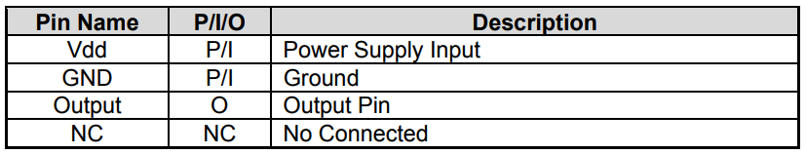

**Functional Block Diagram:**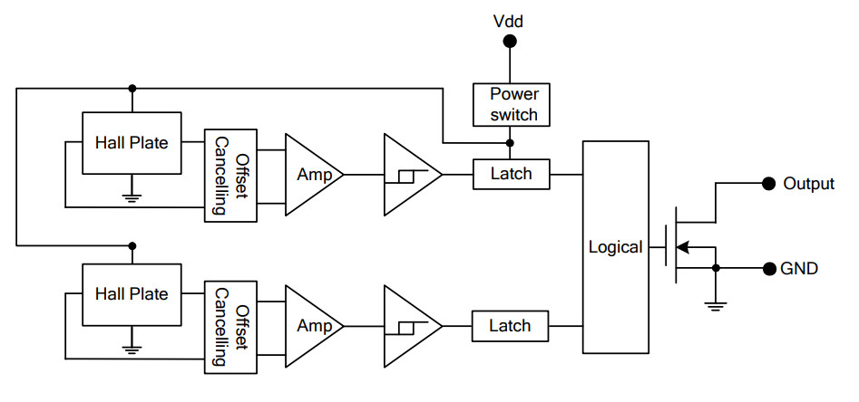

**References:**

1. <http://www.relionbattery.com/blog/7-facts-and-figures-comparing-lithium-ion-vs.-lead-acid-batteries>
2. <http://batteryuniversity.com/learn/article/types_of_battery_cells>
3. <http://www.relionbattery.com/blog/lithium-cells-should-i-go-cylindrical-or-prismatic>
4. <http://www.electrohms.com/product/hk400t03/>
5. <https://www.diodes.com/assets/Datasheets/AH180.pdf>